NOTICE OF MODIFICATION
ROAD TRAFFIC REGULATION ACT 1984
LANCASHIRE COUNTY COUNCIL
(LIGHTFOOT LANE, FULWOOD, PRESTON CITY) (ROAD HUMPS)
NOTICE IS HEREBY GIVEN that Lancashire County Council proposed the above under Section 90A of the Highways Act 1980. Following consultation carried out between 26 February 2021 and 26 March 2021. It is now intended to modify the proposal as titled above, as set out below.
- Remove items 7) and 8) from the proposal.
- Insert the following:
  - Introduce a junction table in Lightfoot Lane and Hazelmere Road, Fulwood, from the intersection of the centrelines for Lightfoot Lane and Hazelmere Road for a distance of 11.7 metres in both an easterly and westerly direction, and for a distance of 8.4 metres in a southerly direction.
The junction table will have a maximum height of 75mm.
  - Introduce speed cushions in Lightfoot Lane, Fulwood, from a point 80.3 metres east of its junction with the centreline of Hazelmere Road for a distance of 3.5 metres in an easterly direction.
The speed cushions will have a maximum height of 75mm.

Statement of Reasons
Traffic calming features are proposed to complement the existing 20mph speed limit and enhance road safety so by discouraging the route to through traffic. Speed cushions have been identified as being the most suitable form of calming feature to have a positive effect on vehicle speeds whilst retaining residential driveway access.

Due to savings made in a related scheme, additional money has been identified which allows for a junction table to be introduced at the junction of Lightfoot Lane and Hazelmere Road. This would require two previously proposed speed cushion pairs to be removed from the proposals and a further pair of speed cushions to be relocated close to the junction of Lightfoot Lane and Lightfoot Close.

A copy of the relevant notice and plan, indicating the proposal may be inspected on Lancashire County Council's website at http://www.lancashire.gov.uk/roads-parking-and-travel/roads/roadworks-and-traffic-regulation-orders/permanent.aspx
Documents can also be requested by email at tro-consultation@lancashire.gov.uk, or in writing to The Director of Corporate Services, Lancashire County Council, P O Box 78, County Hall, Preston PR1 8XJ quoting ref: LSG4/894.12826/AFR.

Note. The above alternative arrangements for the inspection of deposited documents are connected with the effects of the COVID-19 pandemic.

Any representations or objections (specifying the grounds on which they are made) relating to the proposal must be made in writing and should be sent to The Director of Corporate Services, Lancashire County Council, P O Box 78, County Hall, Preston PR1 8XJ or by e-mail to tro-consultation@lancashire.gov.uk quoting ref: LSG4.AFR.894.12826 before 18 June 2021.

Laura Sales, Director of Corporate Services
21 May 2021
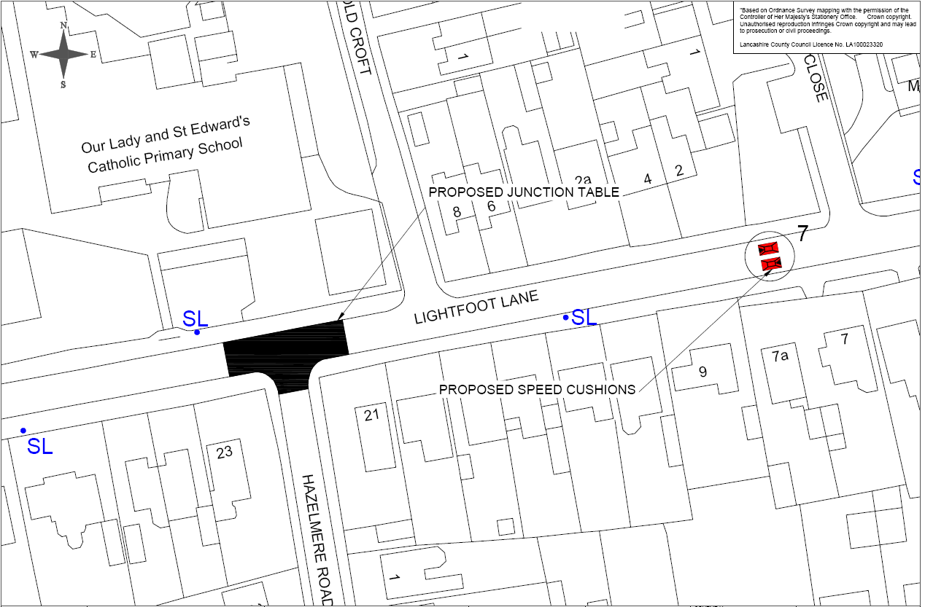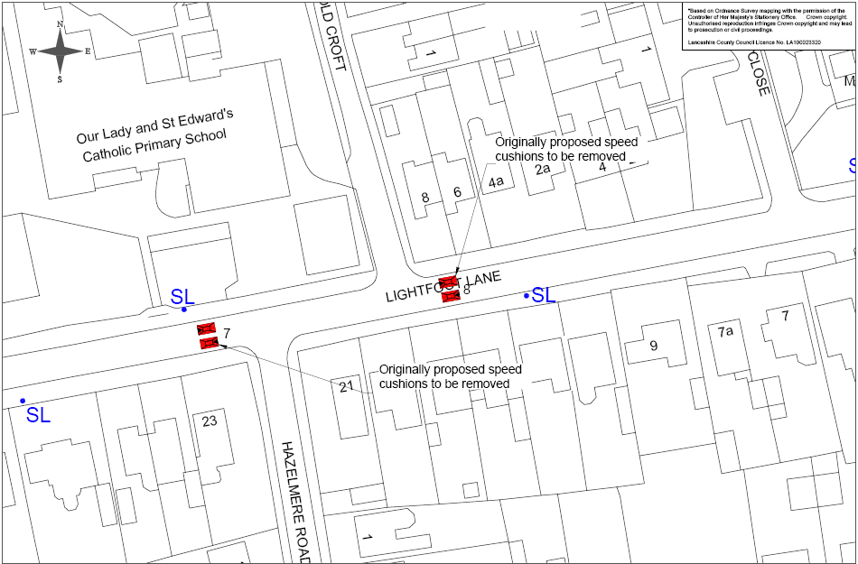
Based upon Ordnance Survey data with the permission of the Controller of Her Majesty's Stationery Office Crown Copyright Licence No 100023520 Unauthorised reproduction infringes Crown Copyright and may lead to prosecution or civil proceedings.
Based upon Ordnance Survey data with the permission of the Controller of Her Majesty's Stationery Office Crown Copyright Licence No 100023520 Unauthorised reproduction infringes Crown Copyright and may lead to prosecution or civil proceedings.

